History of Shickley

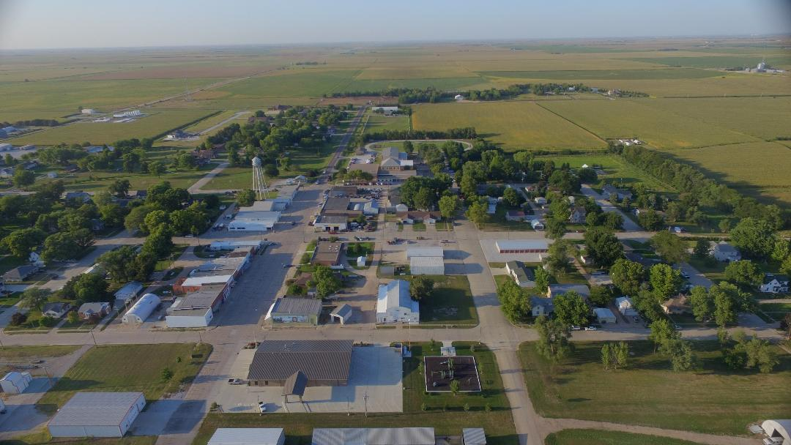

Submitted from:
“Shickley- Then and Now”
with editing by Janet Benson

Before the early pioneers to the Shickley area, the land was hunting ground for the Pawnee and Oto Indian tribes. In 1875, after ceding their remaining territory to the United States, the Pawnee moved to reservations in Oklahoma, the Oto following in 1881. There is no evidence of camps in this area. After the passage of the Homestead Act in 1862 and the close of the Civil War in 1865, the late sixties saw pioneers coming to south-central Nebraska. They came from eastern states by covered wagons or by river barge or steamer or rail to points on the Missouri River until in the fall of 1871 the Burlington Railroad completed its track across the north part of Fillmore County. This brought an influx of settlers to this area and the county was organized and county officers elected in 1871. In 1873, the county was divided into precincts or townships--16 in number, each six miles square. Bryant, the township in which Shickley subsequently was located, is in the southwest corner, legal description, Township 5 North and Range 4 West of the 6th Principal Meridian. Some of the earliest settlers in the area were: Edy Randall, who settled on Section 28, Town 5, Range 4 west, Bryant Precinct, building the first frame house in the spring of 1872. Swan Johnson came in 1883 and Olof Swenson purchased NW 1/4 of Sec. 35 in 1883. William Kline and Robert Campbell owned the properties that Shickley was built on.
During the 1870’s many settlers, Swedish emigrants predominantly, came to Bryant Township. Drought and grasshoppers halted settlement for a time in the early part of the decade and caused some who had already staked claims to relinquish them and return east.
In 1885, the Burlington surveyed for a branch line to run from Beatrice west to Holdrege. It seemed for a time that there would be a trade center established near the Stockholm Church, which was the Swedish Community Center. However, due to the generous offers of William Kline and Robert Campbell. Who owned farms on Section 12 in Bryant Township two and one half miles east of Stockholm, a site for a village was laid out on their land. The town was named “Shickley” from a man by that name who worked for the railroad and played an important part in establishing the village and getting it laid out. A post office was organized and R.B. Campbell was appointed the first postmaster.

The village was platted with the Burlington tracks dividing it into two parts. Mr. Kline owned the land on the south side of the railroad and Mr. Campbell that on the north side. Each man tried to interest investors in either businesses or homes to choose his land and for several years this competition existed. The town was incorporated March 20, 1888, with a population of 200. This same year the North Western Railroad Company surveyed for a branch line to run from Superior to Fremont crossing the four south blocks of the original town. At first most of the business places were located facing Market Street in the two blocks between the Burlington and North Western railroads but gradually the trend was to the blocks on Market Street north of the Burlington. By 1910, much of the south blocks had become residential.
The Census Bureau shows the population of Shickley to have been thus through the years: 1890 - 307; 1900 - 372; 1910 -429; 1920 -396; 1930-389; 1940-342; 1950-316; 1960-371, and remaining stable thereafter. With the advent of automobiles, garages and gas stations were established. The first garages were those of McElroy and Russell and Charles Bergquist, who later sold to Fred Geise. Chris Gratopp, W.C. Milroy and Emil Krause were owners of early cars.
At the time communities were being developed in this area, Mr. George W. Holdrege, the president of the sub-district for the Burlington and Missouri Railroad, had the matter of naming the towns. Vincent C. Shickley, who was engaged in buying right-of-way for the railroad and locating towns for the Lincoln Land Company, was in charge of construction as well as operations locally. The village was first named Vint (Vincent’s nickname) until the post office objected.

Mr. Holdrege then suggested the name Shickley in honor of Vint’s father, Benjamin Franklin Shickley, who at the time was County Judge of Fillmore County. Benjamin Franklin Shickley was born at Lancaster, Pennsylvania, on Feb. 5, 1832. His parents. Peter and Mary Shickley, who were of German descent, were also born at Lancaster. His father’s family emigrated from there in 1839 to Lebanon, Warren County, Ohio, where they resided until 1851 when they removed to the adjoining county of Greene, where his father died in 1875 and his mother in 1907.
Benjamin received his education at several institutions of learning in the two counties of Warren and Greene. He studied law with Judge l.A. Sexton of Xenia, Ohio and was examined and admitted to practice by the Supreme County of the State of Ohio. Among the civil offices held by him in Ohio were Mayor, Justice of the Peace, police judge, probate judge, county judge, enrolling officer, assistance Provost Marshal and recruiting agent, the last three named being United States civil offices. Both he and his father were veterans. Benjamin served with the 74th Ohio Volunteers rising from the rank of private in Company H to Lieutenant Colonel. On Jan. 18, 1855. lie was married to Minerva Mahin of Jamestown, Ohio, a buckeye lady of Irish descent. To this union were born five sons: Frank S., 1856; Alfred W., 1858; John M.. 1869; Charles W., 1861 and Vincent C., 1864. All were born in Ohio. He moved to Nebraska, chiefly for the benefit of Mrs. Shickley's health, in 1876. He came highly recommended for his honesty and ability by all of the county officers, many attorneys. Merchants and bankers at his old home. He was elected and served as Fillmore County judge from 1879 to 1887. Judge Shickley, as he was known, was a member of the Geneva Methodist Church, the Grand Army, Sons of Veterans, and Odd Fellows, as well as the Nebraska Bar Association. He passed away at his home in Geneva, Friday. July 11. 1902. Burial was in the Geneva Cemetery.
Submitted by Kathy Berg
*****************************************************************************
In 1920, there were four elevators, District No. 54 School and four churches. Each railroad had two passenger, mail and express trains and two freight trains daily. From 1915 to 1922. The community supported a picture show regularly. With the corning of automobiles and better highways, Shickley was no longer the only trade center for the community and there were many changes in business ownership between 1920 and 1930. The general merchandise stores became groceries, the bakery gave way to trucked-in bread and there were no hotels but two cafes instead. In 1930, the Farmers and Merchants Bank was bought by the State Bank which still serves the area. The weekly newspaper, the Shickley Herald, was discontinued in 1922 and the county paper published in Geneva disseminated the news. The Congregational and Swedish Methodist Churches discontinued regular worship services in the 1920’s because of small memberships and their church properties were sold and removed eventually. That left the Methodist and Zion Lutheran and several rural churches to serve the community. Stockholm Lutheran, two and one-half miles west of town; the Salem Mennonite. four miles southeast; the Bethel Brethren, four miles south on the county in Thayer County, and St. Mary’s Catholic, which since moved to town. In 1923, the town voted bonds to wire the village for electricity and contracted with the Blue Valley Power Company for current. In 1940, a water system was installed at a cost of $32,000, half of the cost being supplied by the Works Progress Administration. A sewer system and disposal plant for the town were installed in 1954 at a cost of $83,000. Paving the town began with Market Street in 1969, with others following. The town had phone service in 1903 with service from the Fillmore County Telephone Co. and the Shickley-Ong Trunk Line Co. and Shickley-Geneva Trunk Line Co. providing long-distance service. The Lincoln Telephone and Telegraph Co. purchased the exchange in 1913. The dial system was first brought to town on Oct. 9. 1962 at 9 am.
A building that has played an important part in the social and recreational life of Shickley is the old livery barn located on North Railroad Street facing the park. It was originally a livery stable and in the twenties was converted to a community hail. The west third of this building housed the public library and the club room and kitchen of the Federated Woman’s Club. These quarters were once used as kindergarten facilities, also. The library was founded by the Woman’s Club in 1923. But is now supported by a village tax levy. The library has since moved to their own quarters on Market Street, in the old Farmers & Merchants Bank building. The rest of this, floored with maple, was used for a skating rink for many years. Later the floor was tiled and used for basketball before the new school gymnasium was built. It was later sold to the city for $1 and houses city equipment and supplies.
The businessmen have been more or less consistent in keeping a Commercial Club going, and its interest has always been to promote anything for the betterment of the community. Sonic of these concerns have been better lighting and improved streets. Saloons in Shickley date back to the 1890’s. There usually being one place of business, but at one time there were two saloons loons, one on each side of Market Street. There have been intervals when the town was “dry” and until recent years no hard liquors have been sold. In 1981, a liquor license was issued to Ken’s Corner. The people of this community have always been sports minded and have backed many winning teams in basketball, baseball and softball. During the drought and depression years of the thirties. Kitten ball was played on a lighted field by both sexes and there was keen competition from neighboring teams. This was a real morale lifter for everyone in those depressing years. Additional amusements were croquet. Tennis and horseshoes. These games were often played with Zeal into the “wee small hours.” Shuffleboard, too, had a following for a season or two. Early firefighting equipment was a hose cart and bucket brigade with the water supply coming from cisterns kept filled by the town pumps powered by windmills. One was on the corner of Market and North Railroad Street and the other on the corner of Market and Campbell. At one time Shickley was known as “Little Holland,” because of its many windmills. After the Johnston fire, the need of better fire-fighting equipment was emphasized and in May of 1932, a Volunteer Fire Department was organized. There were 25 original members. The first truck was bought in the summer of 1932, a Chevrolet equipped with a chemical tank, hose and buckets. In 1946, a pumper, a 1941 Chevrolet was purchased, in 1956, the Rural Fire District purchased and put in use the tank truck, a 1947 International. The department purchased a 1963 pumper jointly with the rural fire district. In 1981, a fully-equipped Ford rescue unit was purchased. Before 1950, the fire equipment had all been kept in the town hall building, present site of the new fire station. In 1950, the present fire hall was built, and at this writing, a new fire hall is being constructed. It also realized that an ordinance was needed to prevent further construction of wood frame buildings in the business district. This was passed and all future buildings were built of brick.
There was a town marshall from early days to the mid-’70’s, usually having to combine his duties with maintenance duties. A list of these men follows: David Butler, 1892; T.S. Brown, 1902; Seth Lillidol, 1907; Joe Boe, 1908; Tony Heizler, 1913; John Schoenholtz; Charles Kreger; Charles Gratopp, 1930’s; Peter Schrock; Lou Gratopp; Don Wittmack; Gaylord Gowen; Arthur McDaniels, 1967; George Hartman, 1967; Don Richardson.
In 1965, a new addition to the town was platted and several new houses filled this area, this area being known as the Steider addition. Again, in 1982, Clyde Swartzendruber platted a new section north of town and several new houses and two churches are in this section.
Shickley and many communities like her came into being because of the railroads and until the automobile were dependent on it. Through the years, however, the economy changed to an ag-based one and in such an economy, weather plays a major role. In 1896, there was a bumper corn crop which resulted in long cribs for storage being built on the right-of-ways. Corn was sold for 13 cents a bushel. The drought of the 1930’s aggravated by huge storages maintained by the two grain companies are testimony to the value of deep-well irrigation. The “recession” of national depression found Shickley at low ebb. In 1930, the assessed valuation of the town was $215,499, while in 1940, it was $194,144. A recovery from this condition came with the use of deep wells for irrigation. Geologists have long told us of the lake of water underlying this area, and in 1936 the first well was drilled on the Charles Flory farm, tapping this wonderful supply for irrigation. The growing season of 1937 showed its worth in insuring plenty of moisture for crops. From this beginning, all of Shackle’s trade territory is well dotted with deep wells which have been drilled through the years. John B. Alfas was a pioneer in this industry, self-constructing and assembling deep-well equipment and being the first in Fillmore County to get into the business. Fertilizing became a necessity and this gave rise to fertilizer distribution businesses. Yields zoomed and the huge storage maintained by the two grain companies are testimony to the value of deep well irrigation. The recession of the 1980’s have slowed, but have not halted, the good life to be found in Shickley, Nebraska.

Submitted from “Shickley- Then and Now” with editing by Janet Benson

Note: The above was taken from "Shickley, Nebraska-THE FIRST 100 YEARS", a book printed for the Shickley Centennial in 1988. A lot has changed since 1988. More will be added to this page at a later date.

